**Experiment no. 6 : To Study Agile Methodology and Test Case Management**

**using JIRA Tool**

**Agile Methodology**

Agile is a software development approach that emphasizes flexibility, collaboration, and customer feedback. It divides work into small, iterative cycles called sprints, allowing continuous improvement and faster delivery.

**Key Principles of Agile:**

* Customer Collaboration → Frequent feedback ensures better product development.
* Iterative Development → Work is broken into short development cycles.
* Quick Adaptation → Teams respond to changes efficiently.
* Continuous Improvement → Regular reviews and refinements improve quality.

**Popular Agile Frameworks:**

1. Scrum → Uses sprints, daily stand-ups, and retrospectives.
2. Kanban → Focuses on visualizing tasks and limiting work in progress.
3. Extreme Programming (XP) → Emphasizes continuous testing and customer involvement.

**Test Case Management in JIRA**

JIRA is a widely used project management tool developed by Atlassian. It supports Agile methodologies and helps in tracking, managing, and executing test cases efficiently.

Installing & Configuring JIRA

1. Visit [Atlassian JIRA](https://www.atlassian.com/software/jira) and sign up.
2. Choose a project type (Scrum/Kanban/Basic).
3. Invite team members and configure workflows.

**Creating a Test Case in JIRA**

1. Navigate to your project and click “Create Issue”.
2. Select Test Case as the issue type.
3. Fill in details:
   * Summary: Short description of the test case.
   * Steps: List the actions to execute.
   * Expected Result: Define the expected outcome.
   * Actual Result (After Execution): Capture actual behavior.
4. Assign the test case to a tester and save it.

**Executing Test Cases in JIRA**

* Navigate to the test case and update the execution status (Pass, Fail, Blocked).
* Attach evidence (screenshots, logs, etc.) if needed.
* Link defects/bugs to the test case for tracking.

**JIRA Integrations for Testing**

JIRA integrates with tools like Zephyr, Xray, and TestRail to enhance test case management. These plugins provide advanced reporting, automation, and execution tracking.

Benefits of Using JIRA for Test Case Management

* Centralized Tracking → Manage test cases, bugs, and development tasks in one place.
* Collaboration → Enables seamless communication between testers, developers, and managers.
* Custom Workflows → Define workflows tailored to project needs.
* Reports & Dashboards → Gain insights into testing progress and quality.



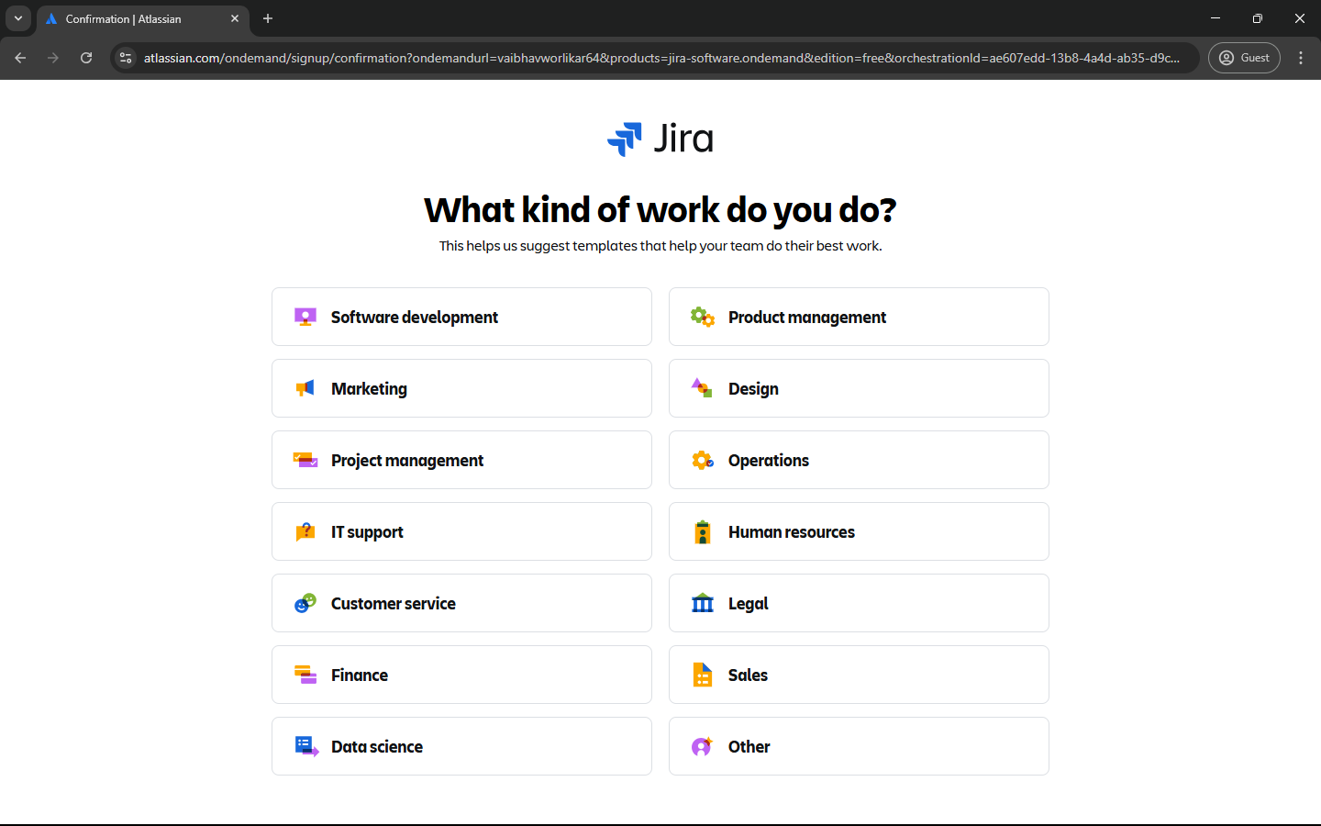

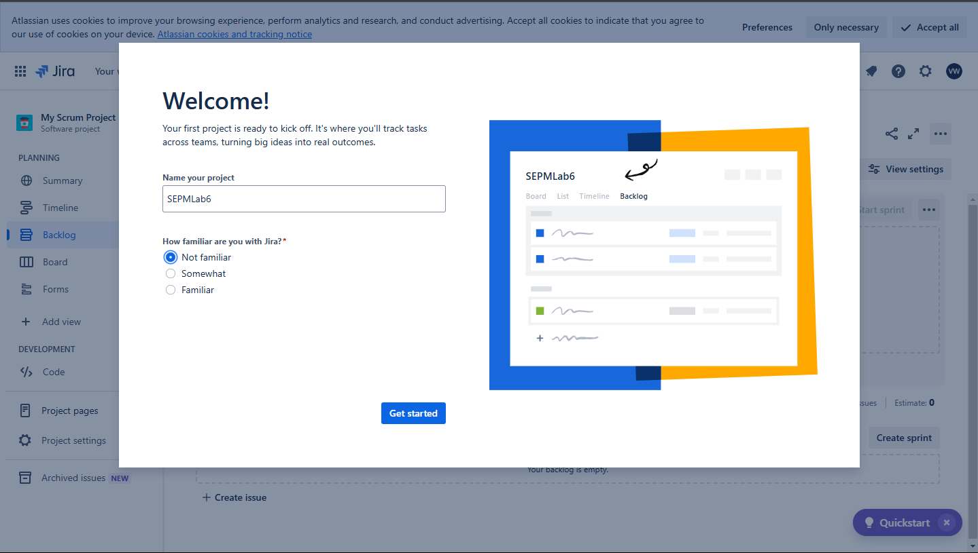

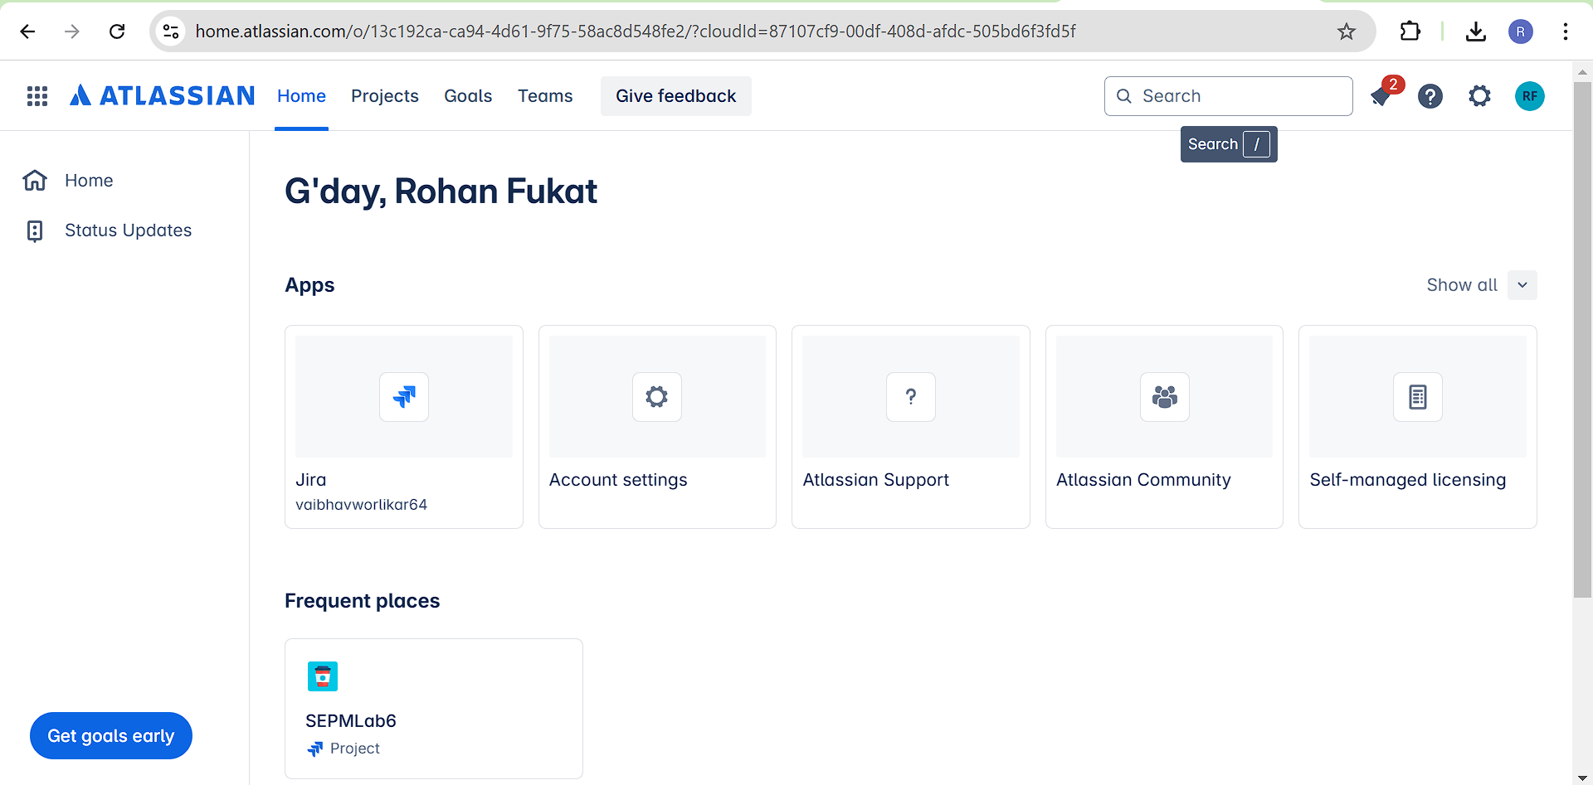

**Conclusion :** Thus, we have successfully studied agile methodology and test case management using jira tool